**Custom Exception in Java**

If any exception is design by the user known as user defined or Custom Exception. Custom Exception is created by user.

**Rules to design user defined Exception**

1. Create a package with valid user defined name.
2. Create any user defined class.
3. Make that user defined class as derived class of Exception or RuntimeException class.
4. Declare parametrized constructor with string variable.
5. call super class constructor by passing string variable within the derived class constructor.
6. Save the program with public class name.java

**Example**

// save by AgeException.java

**package** nage;

**public** **class** AgeException **extends** Exception

{

**public** AgeException(String s)

{

**super**(s);

}

}

**Compile: javac -d . AgeException.java**

**Example**

// save by CheckAge.java

**package** nage;

**public** **class** CheckAge

{

**public** **void** verify(**int** age)**throws** AgeException

{

**if** (age>0)

{

System.err.**print**("valid age");

}

**else**

{

AgeException ae=**new** AgeException("Invalid age");

**throw**(ae);

}

}

}

**Compile: javac -d . CheckAge.java**

**Example**

// save by VerifyAgeException

**import** nage.AgeException;

**import** nage.CheckAge;

**import** java.util.*;

**public** **class** VerifyAgeException

{

**public** **static** **void** main(String args[])

{

**int** a;

System.**out**.println("Enter your age");

Scanner s=**new** Scanner(System.**in**);

a=s.nextInt();

**try**

{

CheckAge ca=**new** CheckAge();

ca.verify(a);

}

**catch**(AgeException ae)

{

System.err.println("Age should not be -ve");

}

**catch**(Exception e)

{

System.err.println(e);

}

}

}

**Compile: javac VerifyAgeException.java**

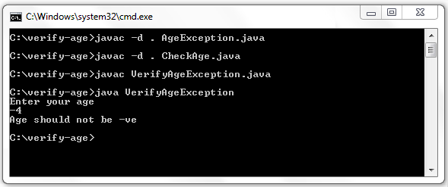**Steps to compile and run above program**

First you save verify-age files into you PC in any where, here i will save this file in C:\>

* C:\verify-age\>javac -d . AgeException.java
* C:\verify-age\>javac -d . CheckAge.java
* C:\verify-age\>javac VerifyAgeException.java

**Note:**First compile AgeException.java code then CheckAge.java and at last compile VerifyAgeException.java code.